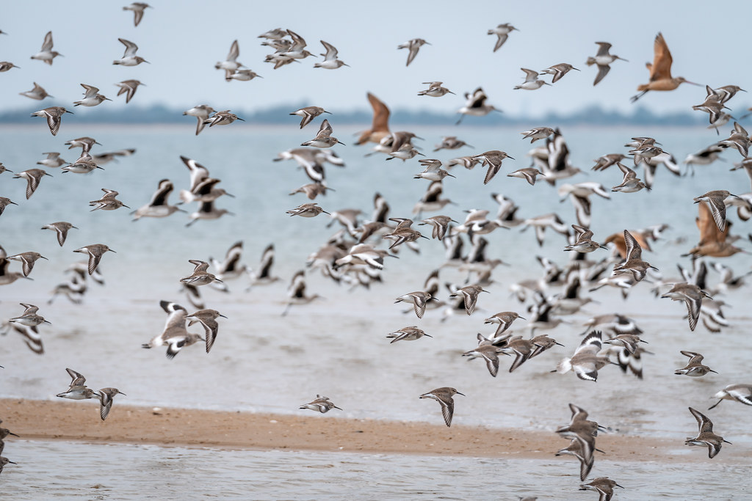

[This Photo](https://www.flickr.com/photos/alchemist_x/46476440694/in/pool-1380392@N25) by Unknown Author is licensed under [CC BY](https://creativecommons.org/licenses/by/3.0/)

Delmira Alzamora